## How to prepare a Demo Video?

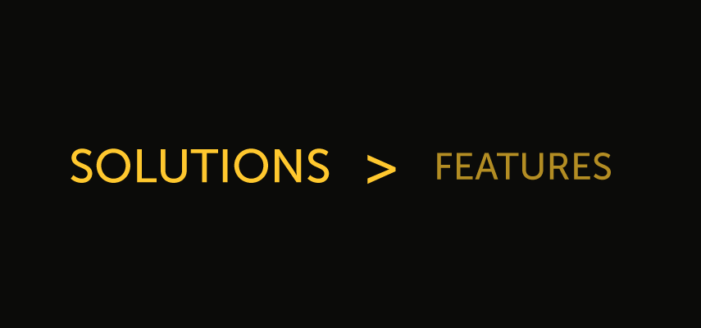

Improve your demo video by focusing on solutions rather than specific features.

I’m sure your product is filled with great features and functionality that all your customers love. It’s tempting to focus on those in your video. I’m here to tell you that you can’t focus on all of them.

For one, there are probably too many to fit in a single video.

Second, they’re features that people love once they know what makes your product so valuable.

And, third, features usually have terminology and jargon that don’t necessarily speak to the problems or pain points the viewer has.

**Think of it like this: features only matter if they solve a problem for your customer.**

Instead of laying out features to show, think solutions.

Why does someone want to use your product? What task are they trying to complete or problem are they trying to solve? This is the key to creating an effective product demonstration. People will listen and invest in your video when they realize you are speaking to their experiences or answering a question, not just showing off a feature set.

## Consider the buyer’s journey

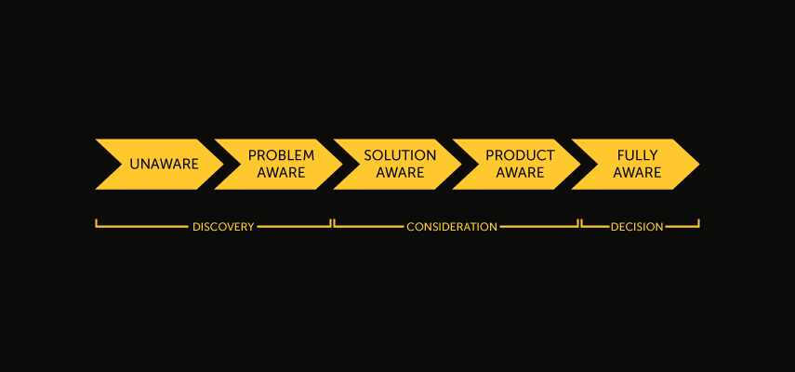

Of course, people might use your software for different purposes. Or, someone might already know the general solution but need a demonstration with more details. This is another reason producing your own product demo is a great choice.

Knowing your audience is key to creating a successful demo. Sales reps may need to see a completely different type of video than end users or decision makers.

You can target different videos at buyers who are at varying points in their [journey](https://www.techsmith.com/blog/nurture-leads-with-video-marketing/) or interested in different aspects of your solution.

Your first demo video will likely be for viewers who are earlier in their journey.

A good starting point is the Consideration phase. This is where they are aware that solutions are available or what your product is, but aren’t ready to buy yet. Your demo video for these potential customers should be more general. Focus on the broad solution your product offers and how it achieves those goals.

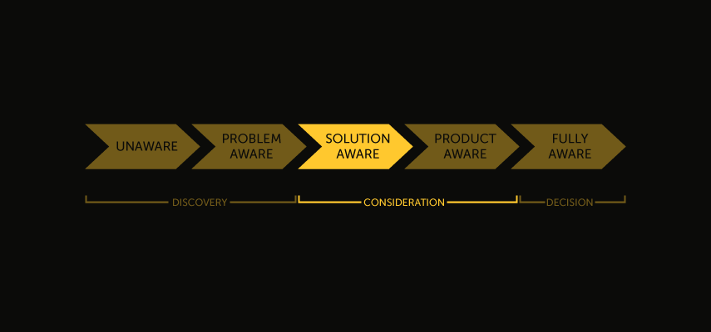

Tell a story in this video. Relate to what has brought a potential buyer to this point, speak directly to their experience, and emphasize the outcomes that your product offers.

After you finish and share your first demo, you can start thinking about a second (and third, and fourth) one. These can speak more specifically to particular buyers, segments, industries, or problems. Buyers at this stage are Product Aware, and likely know of your product along with competitors.

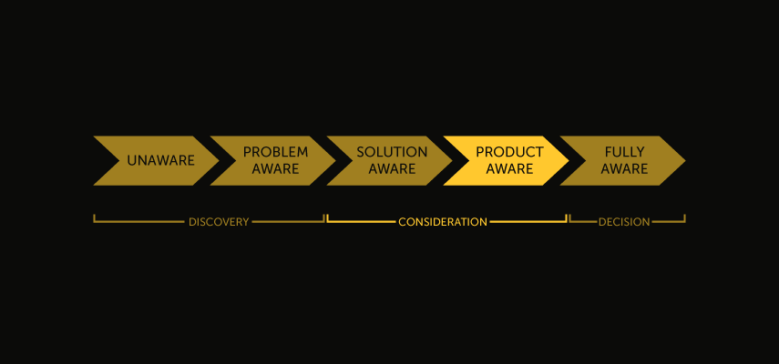

Here you can focus on the particular features that set your offering apart and spend more time demonstrating exactly how your product is used. Buyers at this point must be convinced why your product is the best one on the market.